
COMSATS University Islamabad, Islamabad Campus
Department of Computer Science
Theory Assignment # 03

Course Name: Applications of Information and
Communication Technologies
Instructor Name: Mr. Muhammad Haris
Submitted By: Rubina Mehdi
Group Members: Rubina Mehdi, Subhana Bushra
Registration Number: FA25-BDS-041, FA25-BDS-046
Class/ Section: BDS-1A
Date of submission: 12/5/2025

For the given problems using the problem solving process design the algorithm
Question # 01:
Calculate the age by taking date of birth from the user as input and display age as follows: Your age is XX years, XX months, and XX days
Algorithm:
Step-1 :
Start
Step-2 :
input birth_day, birth_month, birth_year
Step-3 :
Get current_day,current_month,current_year
Step-4 :
age_years = current_year – birth_year
age_months = current_month – birth_month
age_days = current_day – birth_day
Step-5 :
IF (age_days < 0) THEN
age_months = age_months – 1
age_days = age_days + number_of_days_in_previous_month
ENDIF
Step-6:
IF (age_month <0) THEN
age_years = age_years -1
age_months = age_months +12
ENDIF

Step-7 :
Display “Your age is”,age_years, “years, “ , age_months, “ months, and ”,
age_days, “days”
Step-8:
End

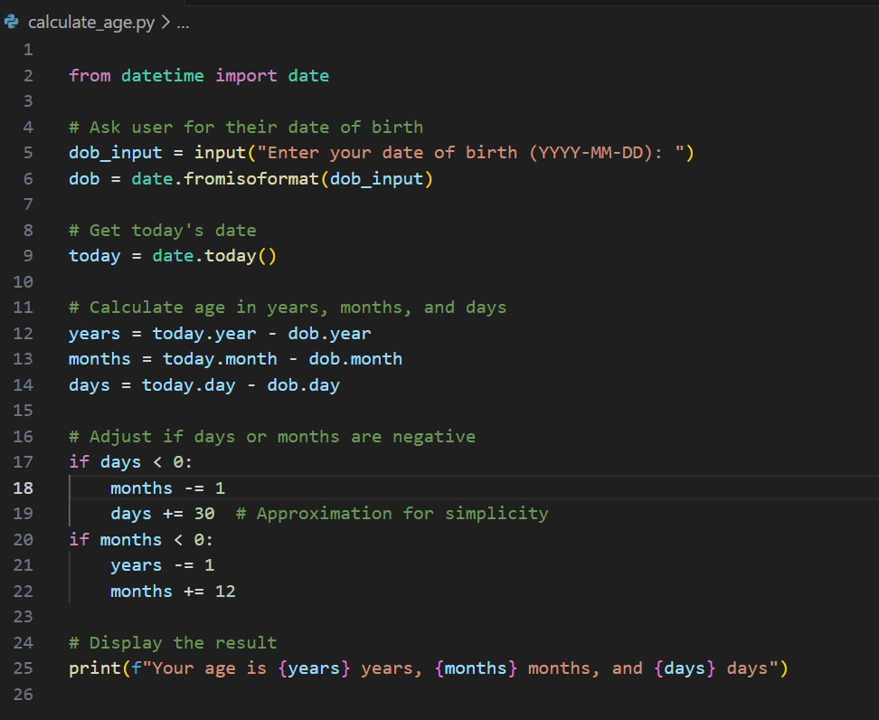

Output:
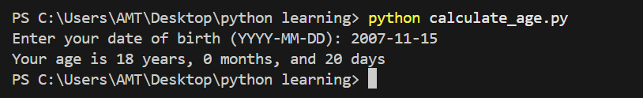

Question # 02:
For any integer received from the user between 0 and 1000, adds all the digits in the integer. For example, if an integer is 932, the sum of all its digits is 14.
Algorithm:
Step-1 :
Start
Step-2 :
Input a number from the user (N)
Step-3:
Initialize sum = 0
Step-4:
Repeat the following steps while N > 0:
a. digit = N % 10 (gets the last digit)
b. sum = sum + digit (adds the last digit to total)
c. N = N // 10 (removes the last digit)
Step-5:
Display the sum
Step-6:
Stop

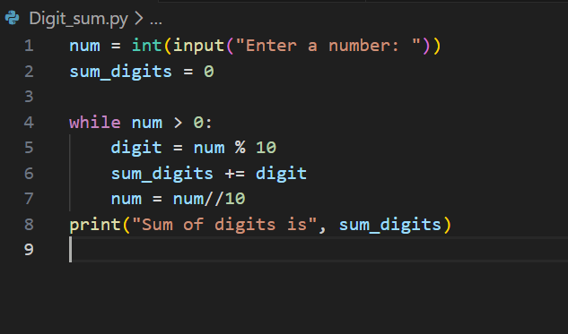

Output:
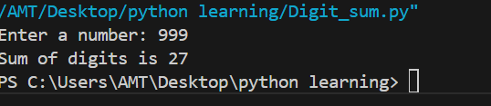

Question 3:
How to determine any number to be even or odd?
Algorithm:
Step-1:
Start
Step-2:
Input a number N from the user
Step-3:
Divide N by 2 and find the remainder (N % 2)
Step-4
IF remainder is 0
THEN
Print "N is even"
ELSE
Print "N is odd"
Step-5:
Stop
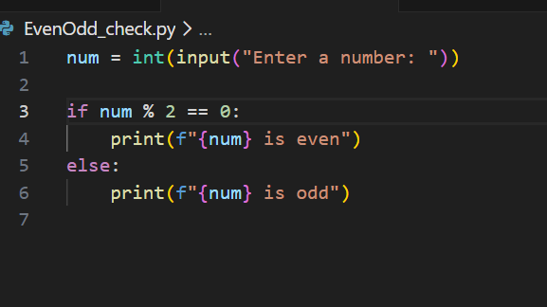
Output:
